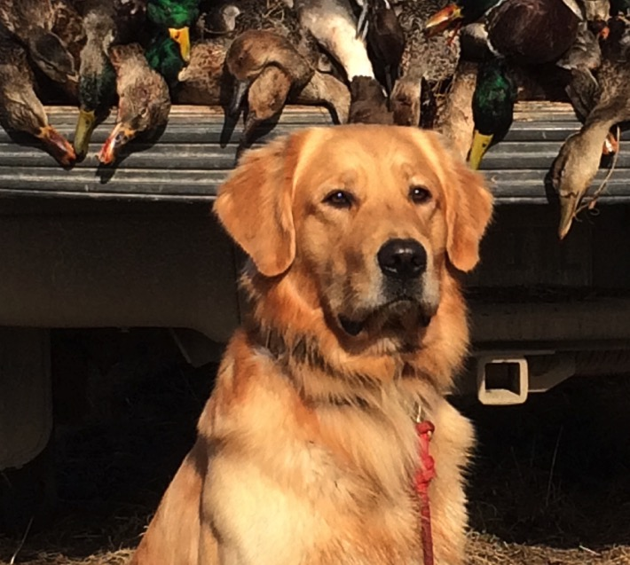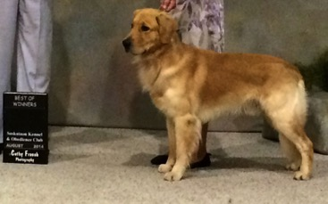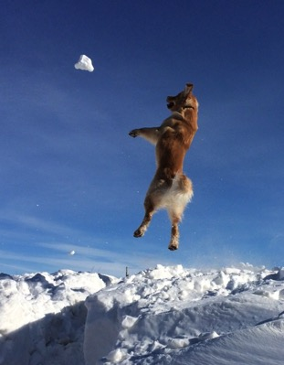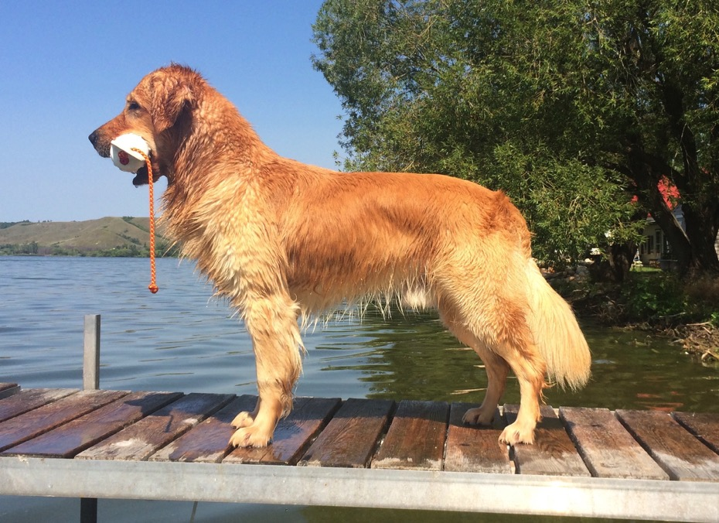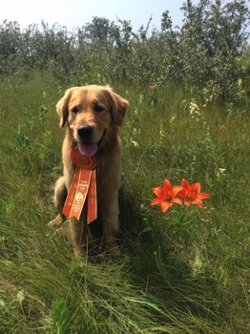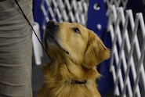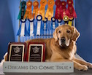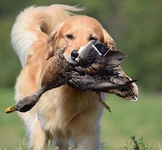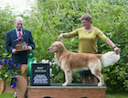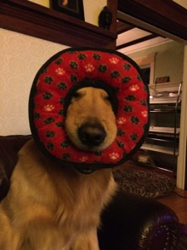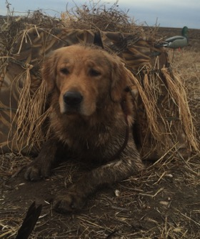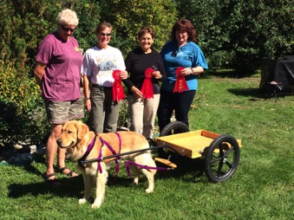

## Jill Cairns

## 2222 Garnet St.

## Regina, SK

## (306) 539-4629

## [jillean@sasktel.net](mailto:jillean@sasktel.net)

## [www.goldnz.ca](http://www.goldnz.ca) (please call or email for stud contract)

### Date of birth: Oct. 14, 2012

### CKC # ZU476839

### AKC # SR76619302

### UKC # R239-960

## ~Versatile

## ~Balanced structure

## ~ Always owner trained and handled

## ~ Classic good looks

## ~ Great hunting partner

## 

## Danno

* **SHR CH Tidewaters Five O Bookem Danno**
* **CGN RA CDX TD WCI DD BDD CAN/AM JH VCX**

# Clearances

# OFA hips – Good

# OFA elbows – Normal

# Cardiac – Normal

# Eyes – Normal

# Prcd-PRA – Optigen clear

# PRA1 – Optigen carrier

# PRA2 – Optigen clear

# Icthyosis – Optigen clear

#### B

#### C

#### A

##### **Silliness and Fun!**

##### I have never known a dog that can make me laugh like Danno does. Everyday. . . and I love him to bits!

2015 - both of the Golden Retriever Club of Canada Versatility Awards. 2016 brought the Follyfoot award for Top Open A obedience.

Danno earned his tracking title on the first try in 2015. The next day he passed again just for fun.

We are currently working on Utility exercises, passing Open 4 for 4.

CKC Grand Champion

2017 GRCC National – Best Gun Dog Award

Danno loves carting and has earned his Draft Dog and Brace Draft Dog titles.

#### D. Quisque Viverra

Nullam nec massa vulputate augue laoreet laoreet. Cconsectetuer adipiscing elit. Mauris ac est a eros iaculis adipiscing.

Nullam nec massa vulputate augue laoreet laoreet. Cconsectetuer adipiscing elit. Mauris ac est a eros iaculis adipiscing.

(item # XXXX) $000.00

(item # XXXX) $000.00

(item # XXXX) $000.00

(item # XXXX) $000.00

(item # XXXX) $000.00

Nullam nec massa vulputate augue laoreet laoreet. Cconsectetuer adipiscing elit. Mauris ac est a eros iaculis adipiscing.

#### E

#### D

#### F

#### C

#### B

#### A

#### C. Vestibulum quam.

#### F. Nulla quis sem.

#### E. Suspendisse congue.

#### A. Aenean elit.

Happiest when he is in his blind, watching for the birds to come in.

AKC and CKC Junior Hunter and HRC Started titles. This boy loves to retrieve!

Danno passed his WC when he was 7 months old! He also has his WCI title.

##### **Working Certificate Tests**

##### **Waterfowl Hunting**

##### **Awards**

##### **Hunt Tests**

##### **Tracking**

##### **Obedience**

##### **Conformation**

##### **Draft Dog**